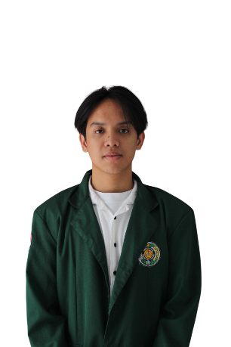

Yusuf Kaisar Salamun Santana

Medan | 082260678080 | ykaisar10@gmail.com | linkedin.com/in/yusuf-kaisar | github.com/YusufKaisar

# EXECUTIVE SUMMARY

Computer Science student passionate about Front End Web Development, with hands-on experience in creating interactive and user-friendly websites through various college projects. Highly motivated, quick to learn new technologies, and eager to improve skills in a dynamic environment. With strong teamwork and communication abilities, I can collaborate effectively with diverse teams to deliver quality results.

# EDUCATION

**Universitas Sumatera Utara** Medan, Indonesia

Student of Faculty of Computer Science and Information Technology. GPA 3.84 September 2022 – Present

**Harapan 3 High School** Medan, Indonesia

Graduated with strong interest in technology and web development. 2019 – 2022

# ORGANIZATION EXPERIENCE

**IMILKOM (Ikatan Mahasiswa S-1 Ilmu Komputer)** Universitas Sumatera Utara

General Chairman Agustus 2024 – Agustus 2025

* Coordinated Organizational Activities: Successfully organized and directed all activities and events within IMILKOM, ensuring that every project and initiative was executed efficiently and aligned with our organizational goals.
* Supervised Task Distribution: Oversaw the distribution of tasks among team members, ensuring that each individual's skills and strengths were utilized effectively.
* Ensured Accountability and Transparency: Maintained accountability for all policies and decisions within IMILKOM. Regularly communicated progres.

Member of Student Affairs Augusts 2023 – Agustus 2024

* **Organized Training and Engagement Events: Planned and executed workshops and initiatives to enhance members understanding of the organization and build a strong sense of belonging.**
* Facilitated Communication and Advocacy: Collected and represented the aspirations of Computer Science undergraduate students to ensure their voices were heard within the organization.
* Ensured Accountability to Leadership: Reported directly to the General Chairman, ensuring tasks were executed according to organizational objectives and policies.

# INTEREST AND LANGUAGES

**Soft Skills:** Leadership, Problem Solving, Teamwork, Critical Thinking, Analytical Skills, Communication Skills, Decision Making, Time Management.

**Hard Skills:** Python, PHP, JavaScript, HTML, CSS, Kotlin, ReactJS, Tailwind CSS, Bootstrap, PostgreSQL, MySQL, Git, REST API Development.

**Languages:** Indonesian (Native Proficiency) and English (Intermediate Proficiency).

# INTERNSHIP EXPERIENCE

**PT Circulartity Center USU**

General Chairman July – August 2025

* Developed and maintained the organization’s website to ensure accuracy, relevance, and smooth functionality.
* Assisted in the frontend development of the organization’s mobile application, implementing features and optimizing performance.
* Collected, prepared, and published digital materials to improve engagement and organizational visibility.

# PROJECT

## Circularity Center USU Website

Build a landing page for Circularity Center USU using ReactJS.

## Bank Sampah Bandar Khalippah Website

A responsive website built with ReactJS as a landing page to provide information about the waste bank program, its services, and benefits to the community.

## ****NLP Tweet Prediction Model****

Built a text prediction model using BERTweet to analyze and predict outcomes from user-typed text.

## Bank Sampah Bandar Khalippah Mobile

An Android application built with Kotlin to manage recyclable waste collection, allowing customers to request pickups, track history, and earn redeemable points from exchanging waste.

## HalalRecipe Mobile

An Android application built with Kotlin that provides a collection of halal food recipes, complete with categories, details, and cooking tutorials.